
FURTHER EDUCATION AND TRAINING CERTIFICATE: INFORMATION TECHNOLOGY: SYSTEMS DEVELOPMENT
ID 78965 LEVEL 4 – CREDITS 165
US ID:9015
LEARNER GUIDE
APPLY KNOWLEDGE OF STATISTICS AND PROBABILITY TO CRITICALLY INTERROGATE AND EFFECTIVELY COMMUNICATE FINDINGS ON LIFE RELATED PROBLEMS

Learner Information:

Details | Please Complete this Section
Name & Surname:
Organisation:
Unit/Dept:
Facilitator Name:
Date Started:
Date of Completion:

Copyright
All rights reserved. The copyright of this document, its previous editions and any annexures thereto, is protected and expressly reserved. No part of this document may be reproduced, stored in a retrievable system, or transmitted, in any form or by any means, electronic, mechanical, photocopying, recording or otherwise without the prior permission.

Key to Icons
The following icons may be used in this Learner Guide to indicate specific functions:
  Books | This icon means that other books are available for further information on a particular topic/subject.
  References | This icon refers to any examples, handouts, checklists, etc…
  Important | This icon represents important information related to a specific topic or section of the guide.
  Activities | This icon helps you to be prepared for the learning to follow or assist you to demonstrate understanding of module content. Shows transference of knowledge and skill.
  Exercises | This icon represents any exercise to be completed on a specific topic at home by you or in a group.
  Tasks/Projects | An important aspect of the assessment process is proof of competence. This can be achieved by observation or a portfolio of evidence should be submitted in this regard.
  Workplace Activities | An important aspect of learning is through workplace experience. Activities with this icon can only be completed once a learner is in the workplace
  Tips | This icon indicates practical tips you can adopt in the future.
  Notes | This icon represents important notes you must remember as part of the learning process.

Learner Guide Introduction
About the Learner Guide… | This Learner Guide provides a comprehensive overview of the APPLY KNOWLEDGE OF STATISTICS AND PROBABILITY TO CRITICALLY INTERROGATE AND EFFECTIVELY COMMUNICATE FINDINGS ON LIFE RELATED PROBLEMS, and forms part of a series of Learner Guides that have been developed for  The series of Learner Guides are conceptualized in modular’s format and developed for  They are designed to improve the skills and knowledge of learners, and thus enabling them to effectively and efficiently complete specific tasks.  Learners are required to attend training workshops as a group or as specified by their organization. These workshops are presented in modules, and conducted by a qualified facilitator.
Purpose | The purpose of this Learner Guide is to provide learners with the necessary knowledge related to APPLY KNOWLEDGE OF STATISTICS AND PROBABILITY TO CRITICALLY INTERROGATE AND EFFECTIVELY COMMUNICATE FINDINGS ON LIFE RELATED PROBLEMS
Outcomes | At the end of this module, you will be able to:  - Apply knowledge of statistics and probability to critically interrogate and effectively communicate findings on life related problems  - Represent analyse and calculate shape and motion in 2-and 3-dimensional space in different contexts  - Use mathematics to investigate and monitor the financial aspects of personal, business, national and international issues
Assessment Criteria | The only way to establish whether a learner is competent and has accomplished the Learning Outcomes is through an assessment process.  Assessment involves collecting and interpreting evidence about the learner’s ability to perform a task.  This guide may include assessments in the form of activities, assignments, tasks or projects, as well as workplace practical tasks. Learners are required to perform tasks on the job to collect enough and appropriate evidence for their portfolio of evidence, proof signed by their supervisor that the tasks were performed successfully.
To qualify | To qualify and receive credits towards the learning program, a registered assessor will conduct an evaluation and assessment of the learner’s portfolio of evidence and competency
Range of Learning | This describes the situation and circumstance in which competence must be demonstrated and the parameters in which learners operate
Responsibility | The responsibility of learning rest with the learner, so:  - Be proactive and ask questions,  - Seek assistance and help from your facilitators, if required.

Learning Unit1
APPLY KNOWLEDGE OF STATISTICS AND PROBABILITY

UNIT STANDARD NUMBER : 9015
LEVEL ON THE NQF : 4
CREDITS : 6
FIELD : Physical, Mathematical, Computer and Life
Sciences
SUB FIELD : Mathematical Sciences

PURPOSE: | This Unit Standard is designed to provide credits towards the mathematical literacy requirement of the NQF at Level 4. The essential purposes of the mathematical literacy requirement are that, as the learner progresses with confidence through the levels, the learner will grow in:  A confident, insightful use of mathematics in the management of the needs of everyday living to become a self-managing person  An understanding of mathematical applications that provides insight into the learner`s present and future occupational experiences `and so develop into a contributing worker  The ability to voice a critical sensitivity to the role of mathematics in a democratic society and so become a participating citizen.  People credited with this unit standard are able to:  Critique and use techniques for collecting, organising and representing data.  Use theoretical and experimental probability to develop models, make predictions and study problems.  Critically interrogate and use probability and statistical models in problem solving and decision making in real-world situations.
LEARNING ASSUMED TO BE IN PLACE:
The credit value is based on the assumption that people starting to learn towards this unit standard al-e competent in Mathematical Literacy and Communications at NQF level 3.

SESSION 1.

CRITIQUE AND USE TECHNIQUES FOR COLLECTING, ORGANISING AND REPRESENTING DATA.

Learning Outcomes
- Situations or issues that can be dealt with through statistical methods are identified correctly.
- Appropriate methods for collecting, recording and organising (data are used so as to maximise efficiency and ensure the resolution of a problem or issue
- Data sources and databases are selected in a manner that ensures the representativeness of the sample and the validity of resolutions.
- Activities that could result in contamination of data are identified and explanations are provided of the effects of contaminated data.
- Data is gathered using methods appropriate to the data type and purpose for gathering the data.
- Data collection methods are used correctly.
- Calculations and the use of statistics are correct.
- Graphical representations and numerical summaries are consistent with the data, are clear and appropriate to the situation and target audience.
- Resolutions for the situation or issue are supported by the data and are validated in terms of the context

Interpreting and analyzing data are problem-solving processes that are essential for dealing with information presented in many different forms, including but not limited to graphs and tables. Visual displays of data are found in reports and in the media, often being used to make decisions or to determine whether to support or reject arguments.
A Problem-Solving Process
The word statistics may bring to mind polls and surveys, or facts and figures in a newspaper article. But statistics is more than just a bunch of numbers: Statistics is a problem-solving process that seeks answers to questions through data.
By asking and answering statistical questions, we can learn more about the world around us. Statistics is used every day to help us gain insight into questions that affect our lives: Is our population growing or shrinking? What is the safest way to invest money? Will eating more fruits and vegetables really make us live longer?
What do you think of when you hear the word statistics?
Four things make a problem statistical: the way in which you ask the question, the role and nature of the data, the particular ways in which you examine the data, and the types of interpretations you make from the investigation. A statistics problem typically contains four components:
Asking a question gets the process started. It's important to ask a question carefully, with an understanding of the data you will use to find your answer. The question is most frequently derived from a problem situation and therefore can be seen as the core focus for the modelling of the data.
Collecting data to help answer the question is an important step in the process. You obtain data by measuring something, gathering relevant information pertaining to the problem situation or even through sampling which is another way to collect data. Experimentation is another.
Data must be organized, summarized, and represented properly in order to provide good answers to statistical questions. Also, the data you collect usually vary (i.e., they are not all the same), and you will need to account for the sources of this variation. The integrity of the source is of utmost importance to ensure for a accurate analysis.
After you analyze your data, you must interpret it in order to provide an answer -- or answers -- to the original question or problem situation.
You will become increasingly familiar with this process as you investigate different statistical problems.
From the recognition of trends to extracting patterns and extrapolating from data are higher-order problem-solving components of data interpretation and analysis. Therefore, before we can start to analyse data we need to understand how to collect the information, organise it effectively and then present it in an easy to understand format.

There are many forms of models which could be used to present and display information for analysis. Selecting the correct one could be critical so as to ensure that the applicable information can be analysed effectively.
Let’s have a look at a few of these examples. As you go through the examples with your facilitator, discuss other possible applications for the use of the models.
Line Graphs
A line graph is a way to summarize how two pieces of information are related and how they vary depending on one another. The numbers along a side of the line graph are called the scale.
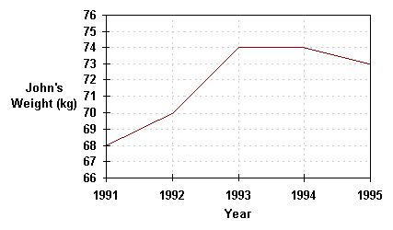
Example 1:

Description: The graph above shows how John's weight varied from the beginning of 1991 to the beginning of 1995. The weight scale runs vertically, while the time scale is on the horizontal axis. Following the gridlines up from the beginning of the years, we see that John's weight was 68 kg in 1991, 70 kg in 1992, 74 kg in 1993, 74 kg in 1994, and 73 kg in 1995. Examining the graph also tells us that John's weight increased during 1991 and 1995, stayed the same during 1991, and fell during 1994.
Use:

Pie Charts
A pie chart is a circle graph divided into pieces, each displaying the size of some related piece of information. Pie charts are used to display the sizes of parts that make up some whole.
Example 1:
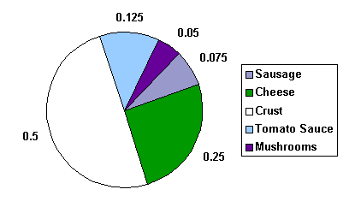
The pie chart below shows the ingredients used to make a sausage and mushroom pizza. The fraction of each ingredient by weight is shown in the pie chart below. We see that half of the pizza's weight comes from the crust. Note that the sum of the decimal sizes of each slice is equal to 1 (the "whole" pizza").

Example 2:
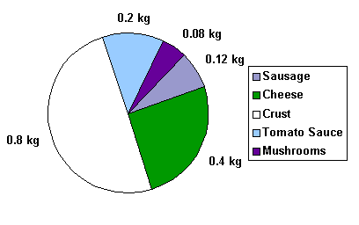
The pie chart below shows the ingredients used to make a sausage and mushroom pizza weighing 1.6 kg. This is the same chart as above, except that the labels no longer tell the fraction of the pizza made up by that ingredient, but the actual weight in kg of the ingredient used. To get the fraction of the pizza made up by any ingredient, divide the weight of the ingredient by the weight of the pizza. What fraction of the pizza does the sausage make up? We divide 0.12 kg by 1.6 kg, to get 0.075. This is the same value as in the pie chart in the previous example.

Example 3:
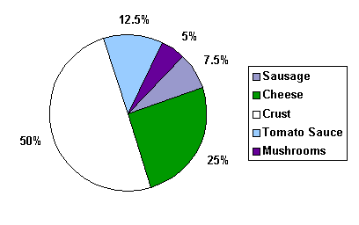
The pie chart below shows the ingredients used to make a sausage and mushroom pizza. The fraction of each ingredient by weight shown in the pie chart below is now given as a percent. Again, we see that half of the pizza's weight, 50%, comes from the crust. Note that the sum of the percent sizes of each slice is equal to 100%. Graphically, the same information is given, but the data labels are different. Always be aware of how any chart or graph is labelled.

Use:

Bar Graphs
Bar graphs consist of an axis and a series of labelled horizontal or vertical bars that show different values for each bar. The numbers along a side of the bar graph are called the scale.
Example 1:
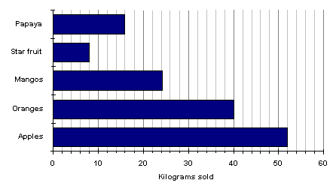
The bar chart below shows the weight in kilograms of some fruit sold one day by a local market. We can see that 52 kg of apples were sold, 40 kg of oranges were sold, and 8 kg of star fruit were sold.

Example 2:
A double bar graph is similar to a regular bar graph, but gives 2 pieces of information for each item on the vertical axis, rather than just 1. The bar chart below shows the weight in kilograms of some fruit sold on two different days by a local market. This lets us compare the sales of each fruit over a 2 day period, not just the sales of one fruit compared to another. We can see that the sales of star fruit and apples stayed most nearly the same. The sales of oranges increased from day 1 to day 2 by 10 kilograms. The same amount of apples and oranges was sold on the second day.
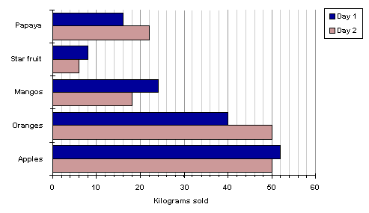

Uses:

SESSION 2.

USE THEORETICAL AND EXPERIMENTAL PROBABILITY TO DEVELOP MODELS.

Learning Outcomes
- Experiments and simulations are chosen and/or designed appropriately in terms of the situation to be modelled.
- Predictions are based on validated experimental or theoretical probabilities.
- The results of experiments and simulations are interpreted correctly in terms of the real context.
- The outcomes of experiments and simulations are communicated clearly.

PLANNING - WORKSHEET
In your groups, think of a general statistical question that could be answered through analysis. Now think carefully about the four steps listed on page 36. Answer the questions below to prepare for your strategic analysis of data to solve the problem or statistical question.
Question 1 – Step 1 (Select a Problem situation for data collection, organising & analysis)
What is the problem situation or statistical question? Write a brief description below.

Question 2 – Step 2 (Identify required data and relevant sources for analysis and presentation)
What data needs to be collected for analysis and presentation in your model? Also list the sources of your data.

Question 3 – Step 3 (Model, present and analyse data)
Which format will you use to model your data to present it accurately for analysis? How will you analyse the data? Write a brief description below.

Question 4 – Step 4 (Interpret results or solutions derived from analysis of data)
How will you interpret the results from the analysis? How will this provide a solution to the problem or answer the statistical question? Write a brief description below.



PROJECT 1
You will now need to complete your own analysis of a problem situation or statistical question. You may select any one of the following two topics:
- CRIME
- HEALTH
Take note of the following guidelines when completing your project:
- You will need to collect data from reliable sources of information to present in your model.
You may also choose to complete your project on a separate sheet of paper and attach it to your Portfolio of Evidence. Alternatively, you can present your data and analysis in the space provided.

Probability Models – Demonstration
Read through the following with your facilitator.
- Make notes of the demonstration provided by your facilitator on the information provided below.
- Ask questions where required.
Introduction
A probability model is a mathematical representation of a random phenomenon. It is defined by its sample space, events within the sample space, and probabilities associated with each event.
The sample space S for a probability model is the set of all possible outcomes.
For example, suppose there are 5 marbles in a bowl. One is red, one is blue, one is yellow, one is green, and one is purple. If one marble is to be picked at random from the bowl, the sample space possible outcomes S = {red, blue, yellow, green, purple}. If 3 of the marbles are red and 2 are blue, then the sample space S = {red, blue}, since only two possible colour outcomes be possible. If, instead, two marbles are picked from a bowl with 3 red marbles and 2 blue marbles, then the sample space S = {(2 red), (2 blue), (1 red and 1 blue)}, the set of all possible outcomes.
An event A is a subset of the sample space S.
Suppose there are 3 red marbles and 2 blue marbles in a bowl. If an individual picks three marbles, one at a time, from the bowl, the event "pick 2 red marbles" can be achieved in 3 ways, so the set of outcomes A = {(red, red, blue),(red, blue, red), (blue, red, red)}. The sample space for picking three marbles, one at a time, is all of the possible ordered combinations of three marbles, S = {(red, red, red), (red, red, blue), (red, blue, red), (blue, red, red), (blue, blue, red), (blue, red, blue), (red, blue, blue)}. Since there are only 2 blue marbles, it is impossible to achieve the event {blue, blue, blue}.
A probability is a numerical value assigned to a given event A. The probability of an event is written P(A), and describes the long-run relative frequency of the event. The first two basic rules of probability are the following:
Rule 1: Any probability P(A) is a number between 0 and 1 (0 < P(A) < 1).
Rule 2: The probability of the sample space S is equal to 1 (P(S) = 1).
Suppose five marbles, each of a different colour, are placed in a bowl. The sample space for choosing one marble, from above, is S = {red, blue, yellow, green, purple}. Since one of these must be selected, the probability of choosing any marble is equal to the probability of the sample space S = 1. Suppose the event of interest is choosing the purple marble, A = {purple}. If it is equally likely that any one marble will be selected, then the probability of choosing the purple marble, P (A) = 1/5. In general, the following formula describes the calculation of probabilities for equally likely outcomes:
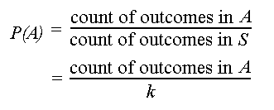
If there are k possible outcomes for a phenomenon and each is equally likely, then each individual outcome has probability 1/k.
The probability of any event A is

SESSION 3.

CRITICALLY INTERROGATE AND USE PROBABILITY AND STATISTICAL MODELS.

Learning Outcomes
- Statistics generated from the data are interpreted meaningfully and interpretations are justified or critiqued.
- Assumptions made in the collection or generation of data and statistics are defined or critiqued appropriately.
- Tables, diagrams, charts and graphs are used or critiqued appropriately in the analysis and representation of data, statistics and probability values
- Predictions, conclusions and judgements are made on the basis of valid arguments and supporting data, statistics and probability models.
- Evaluations of the statistics identify potential sources of bias, errors in measurement, potential uses and misuses and their effects.

Read the following presentation of information carefully then answer the questions to follow to create your own analysis of the data presented in this study.
South Africa's population
South Africa is a nation of over 47-million people of diverse origins, cultures, languages and beliefs.
According to the mid-2006 estimates from Statistics South Africa, the country's population stands at some 47.4-million, up from the census 2001 count of 44.8-million.
Africans are in the majority at 37.7-million, making up 79.5% of the total population. The white population is estimated at 4.4-million (9.2%), the coloured population at 4.2-million (8.9%) and the Indian/Asian population at 1.2-million (2.5%).
South Africa's population by race
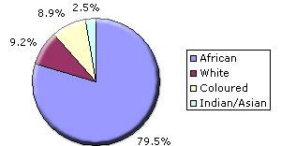
While more than three-quarters of South Africa's population is black African, this category is neither culturally nor linguistically homogenous. Nine of the country's 11 official languages are African, reflecting a variety of ethnic groupings which nonetheless have a great deal in common in terms of background, culture and descent.
South Africa's population by language
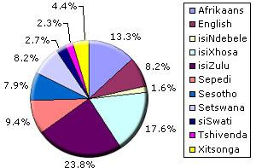

Conclusion
Africans include the Nguni people, comprising the Zulu, Xhosa, Ndebele and Swazi; the Sotho-Tswana people, comprising the Southern, Northern and Western Sotho (Tswana); the Tsonga; and the Venda.
South Africa's white population descends largely from the colonial immigrants of the late 17th, 18th and 19th centuries - Dutch, German, French Huguenot and British. Linguistically it is divided into Afrikaans- and English-speaking groups, although many small communities that have immigrated over the last century retain the use of other languages.
The label "coloured" is a contentious one, but still used for people of mixed race descended from slaves brought in from East and central Africa, the indigenous Khoisan who lived in the Cape at the time, indigenous Africans and whites. The majority speak Afrikaans.
Khoisan is a term used to describe two separate groups, physically similar in being light-skinned and small in stature. The Khoi, who were called Hottentots by the Europeans, were pastoralists and were effectively annihilated; the San, called Bushmen by the Europeans, were hunter-gatherers. A small San population still lives in South Africa.
The majority of South Africa's Asian population is Indian in origin, many of them descended from indentured workers brought to work on the sugar plantations of the eastern coastal area then known as Natal in the 19th century. They are largely English-speaking, although many also retain the languages of their origins. There is also a significant group of Chinese South Africans.
In terms of religious affiliation, about two-thirds of South Africans are Christian, mainly Protestant. They belong to a variety of churches, including many that combine Christian and traditional African beliefs. Many non-Christians espouse these traditional beliefs. Other significant religions are Islam, Hinduism and Judaism.
WORKSHEET - Answer the following questions:
- Describe the possible statistical questions which were addressed in the above analysis.

- Describe the type of data which was used in the presentation.

- What format was used to organise and present the information? What the format appropriate?

- Were you able to interpret the results of the analysis done?

